Special educational needs (SEN) information report


‘Believing, loving, caring, sharing – everyone growing in the light of Christ.’


Approved by: |  | Date:
Last reviewed on: | 20/10/25
Next review due by: | 01/09/26

Contents
Contents 3
1. What types of SEN does the school provide for? 4
2. Which staff will support my child, and what training have they had? 4
3. What should I do if I think my child has SEN? 6
4. How will the school know if my child needs SEN support? 6
5. How will the school measure my child’s progress? 7
6. How will I be involved in decisions made about my child’s education? 7
7. How will my child be involved in decisions made about their education? 8
8. How will the school adapt its teaching for my child? 8
9. How will the school evaluate whether the support in place is helping my child? 9
10. How will the school resources be secured for my child? 10
11. How will the school make sure my child is included in activities alongside pupils who don’t have SEN? 10
12. How does the school make sure the admissions process is fair for pupils with SEN or a disability? 10
13. How does the school support pupils with disabilities? 11
14. How will the school support my child’s mental health and emotional and social development? 11
15. What support will be available for my child as they transition between classes or settings or in preparing for adulthood? 11
16. What support is in place for looked-after and previously looked-after children with SEN? 12
17. What should I do if I have a complaint about my child’s SEN support? 12
18. What support is available for me and my family? 13
19. Glossary 13

Dear parents and carers,
The aim of this information report is to explain how we implement our SEND policy. In other words, we want to show you how special educational needs support works in our school.
If you want to know more about our arrangements for SEND, read our SEND policy.

You can find it on our website The Redeemer CE Primary School - SEND
You can also ask a member of staff to send you the policy.
Note: If there are any terms we’ve used in this information report that you’re unsure of, you can look them up in the Glossary at the end of the report.

1. What types of SEN does the school provide for?
Our school provides for pupils with needs across all four areas identified in the SEND code of practice. Every school is required to identify and cater for the SEND needs of pupils and Blackburn the Redeemer caters for children with needs in communication and interaction, cognition and learning, sensory and/or physical disabilities and social emotional and mental health.
Area of need | Condition
Communication and interaction | Autism spectrum disorder (ASD)
Communication and interaction | Speech and language difficulties
Cognition and learning | Specific learning difficulties, including dyslexia, dyspraxia, dyscalculia
Cognition and learning | Moderate learning difficulties
Cognition and learning | Severe learning difficulties
Social, emotional and mental health | Attention deficit hyperactivity disorder (ADHD)
Social, emotional and mental health | Attention deficit disorder (ADD)
Sensory and/or physical | Hearing impairments
Sensory and/or physical | Visual impairment
Sensory and/or physical | Multi-sensory impairment
Sensory and/or physical | Physical impairment

2. Which staff will support my child, and what training have they had?
Our special educational needs co-ordinator, or SENCO
Our SENCO is Natalie Woodhouse
She has four years’ experience in this role and has also worked to support other schools in our Local Authority as their SENCO as and when needed. She has been a qualified teacher for thirteen years and has taught all year groups from Reception to Year 6. Mrs Woodhouse has had training in sensory needs, understanding Autism and ADHD, Attention for Learning, supporting children with specific learning difficulties, is part of the SENCO cluster, is part of the SEND Learning Network and has previously been on the EHCP panel in 2024-2025. She is also CAF lead at The Redeemer and is a trained Designated Safeguarding Lead.
Mrs Woodhouse received the National SENCO award in 2021.
She is allocated three days a week to manage SEN provision.

Other members of staff working within the SEND team.
Our family support worker, wellbeing lead/ ELSA is Kay Mayfield.
She has six years’ experience working in this role as well as being a teaching assistant for fourteen years prior to that.
Kay has mental health training, CAF training, ELSA training, Nurture training, bereavement training and is a senior mental health lead, prevent lead, as well as one of school designated safeguarding leads and runs staff supervision. Kay is joint lead on the Attendance team alongside Amanda Jones.
Kay is allocated five days a week to support the wellbeing of children, staff, and parents

Class Teachers
All of our teachers receive in-house SEN training, and are supported by the SENCO to meet the needs of pupils who have SEN. Quality First Teaching is provided for all children in school and is the pinnacle to ensuring that children progress effectively.
The Redeemer has been part of the PINS project, making changes across school to cater for all children with neurodiversity.
Staff receive support from our Local Authority Advisory Teacher’s of SEN in order to ensure that staff make all reasonable adjustments/ follow specific interventions for children with identified SEN needs, and follow adaptive teaching strategies (Rosenshein’s Principles) in order to meet the needs of all learners.
Teaching assistants (TAs)
We have a team of twenty teaching assistant’s including one higher-level teaching assistants (HLTA) and a School Based Tutor, who are all trained to deliver SEN provision.
We have specific teaching assistants who are trained to deliver interventions such as Attention for Learning, Sensory Stories, Kickstart and Ready Steady Listen, Super Talkers, Blank Level Language intervention, Adaptive teaching Strategies, School based physio, Physical Development interventions, Body Awareness Precision Teaching, colourful semantics, and delivering Speech and Language interventions.
In the last academic year, TAs have been trained in adaptive teaching strategies, Attention for Learning, and Super Talkers.
External agencies and experts
Sometimes we need extra help to offer our pupils the support they need. Whenever necessary we will work with external support services to meet the needs of our pupils with SEN and to support their families. These include:
- Speech and language therapists
- Educational psychologists
- Occupational therapists
- GPs or paediatricians
- School nurses
- Child and adolescent mental health services (CAMHS)
- Education welfare officers
- Social services and other local authority (LA)-provided support services
- Voluntary sector organisations
- Advisory Teachers from the Local Authority including, ASD, DLD, EYFS, SPLD, PD.
- PINS project

3. What should I do if I think my child has SEN?
We follow specific procedures in school when staff/ parents feel a child may have a SEND need and ensure that a collaborative approach is used in the identification, support, and further decision making based on those needs. We ensure that parents/carers are kept up to date as they are an integral part of their child’s education, therefore, we will only do what the family are comfortable with.

If you think your child might have SEN, the first person you should tell is your child’s teacher.  You should get in touch with your child’s teacher through Class Dojo or by organising a meeting.  They will pass a message on to the SENCO, who will support the class teacher in adding reasonable adjustments to the classroom to support this need and then monitor.  You can also contact the SENCO directly through Class Dojo or by booking a meeting but this should only be if the class teacher has already been seen. | We will meet with you to discuss your concerns and try to get a better understanding of what your child’s strengths and difficulties are.  Together we will decide what outcomes to seek for your child and agree on next steps.  We will make a note of what’s been discussed and add this to your child’s record. You will also be given a copy of this.  If further support is needed, the SENCO will conduct SENCO assessments which will lead to a SENCO recommendation form being shared with class teacher and parents with the outcome of those assessments and whether these have indicated any SEN need. | If we decide that your child needs SEN support, we will formally notify you in writing and your child will be added to the school’s SEND register and you will sign to say that you agree with this.  School will follow the recommendations for adaptations in lessons and interventions for a child and a review of progress will happen within 3 months.

4. How will the school know if my child needs SEN support?
All our class teachers are aware of SEN and are on the lookout for any pupils who aren’t making the expected level of progress in their schoolwork or socially. This might include struggling with phonics/ reading/ writing, noticing that understanding of language doesn’t seem to be secure, noticing differences in the way a child speaks, noticing signs that a child is not coping and is making inappropriate requests for attention, or observing social difficulties.
Children in Reception are all baselined on receptive language, abstract language understanding (BLANK), WELLCOMM, and gross and fine motor. Interventions can then instantly be started for any pupils having difficulties.
If the teacher notices that a pupil is falling behind, they try to find out if the pupil has any gaps in their learning. If they can find a gap, they will give the pupil extra support to try to fill it. Pupils who don’t have SEN usually make progress quickly once the gap in their learning has been filled.
If the pupil is still struggling to make the expected progress, the teacher will put in place ‘reasonable adjustments’ to support the individual learner with/without the support of the SENCO. The class teacher will notify parents that they have implemented those strategies. The teacher will talk to the SENCO, and will contact you to discuss whether you consent to the SENCO conducting assessments. If you consent to this, you will be asked to comment on whether you feel your child has any difficulties or not. The class teacher will put in a SENCO referral form highlighting the strengths, needs, reasonable adjustments, parent voice, pupil voice, and where the child needs support. (please see below.)
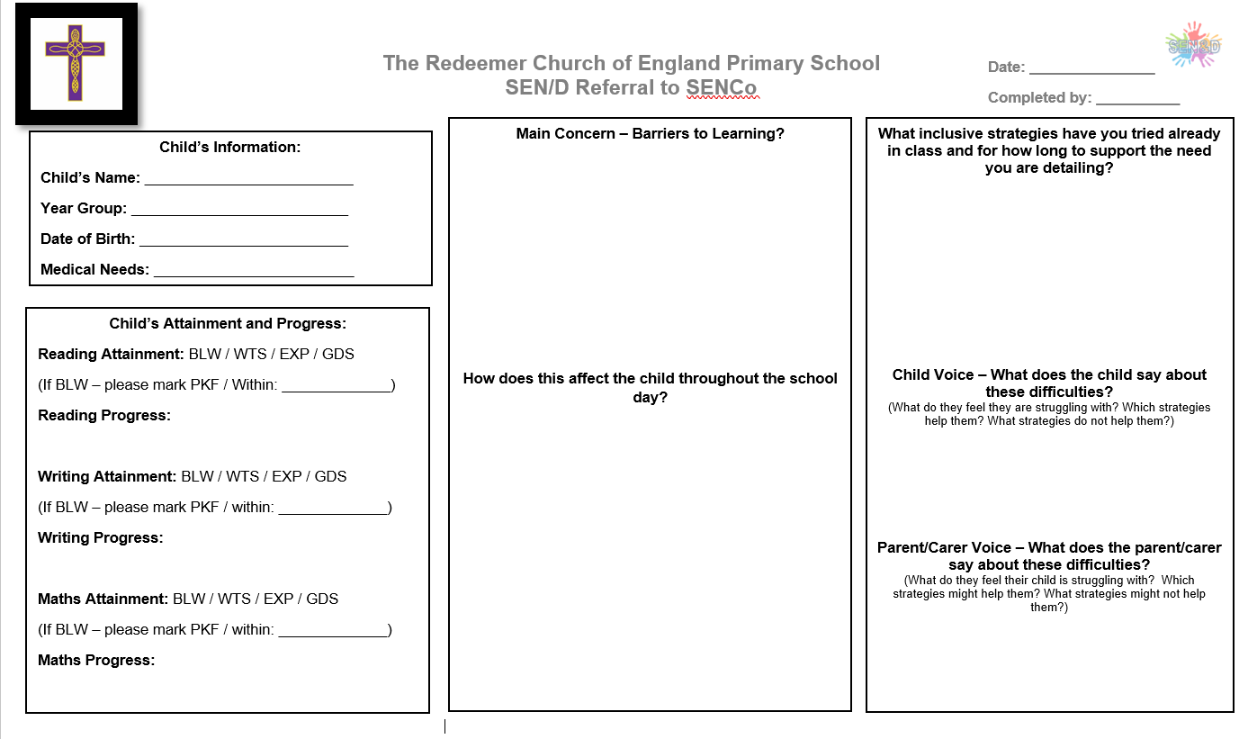
The SENCO will observe the pupil in the classroom and in the playground to see what their strengths and difficulties are. They will have discussions with your child’s teacher/s, to see if there have been any issues with, or changes in, their progress, attainment or behaviour. They will also compare your child's progress and development with their peers and available national data.
The SENCO will conduct a range of assessments in whatever area your child seems to be showing need. These assessments are as follows: Language assessments
- BPVS- receptive vocabulary
- TALC- understanding of abstract questioning and language.
- Word Level- assessment of how many words your child can understand within instruction.
- DLS- word carrying level and RST- language comprehension and word category understanding (prepositions, verbs)
- WELCOMM- a test designed to assess vocabulary, narrative, comprehension, expressive language.
- Word finding- assessing whether your child can access known words using pictures.
- RAPT- an assessment of expressive language- information and grammar.
- Bus story- fluent narrative assessment.
- Speech sounds assessment- to see whether your child needs specific speech sounds supported by SALT.
Cognition and learning assessments
- YARC- levels of reading rate, speed and comprehension
- RFS- reading for sounds- assessment of whether children are ready to access phonics and where gaps lie.
- RAVENS- ability to problem solve with no language needed.
- PHAB2 fluency- assessment of fluency.
- Memory- assessment of working memory and memory.
- Portfolio- a screener designed to see if your child is at risk of dyslexia and where their strengths and needs lie within literacy skills
- Visual perception- assessment of how the brain processes what it sees.
- SANDWELL- maths ability assessment.
Physical and sensory.
- Baseline motor assessment- assessing fine and gross motor
- Sensory profile- assessing whether children have needs within their sensory system and how to combat that in school and home.

SEMH
- Boxall profile- emotional development
- 3 islands- an activity that helps your child explain who/ what they value and who/what they have challenges with.

The SENCO will ask for your opinion and speak to your child to get their input as well. They may also, where appropriate, ask for the opinion of external experts such as a speech and language therapist, an educational psychologist, or a paediatrician.
Based on all of this information, the SENCO will decide whether your child needs SEN support. You will be told the outcome of the decision in writing and will be asked to sign for them to be added to the SEND register.
If your child does need SEN support, their name will be added to the school’s SEND register, and the SENCO will work with you to create a SEN support plan for them.

5. How will the school measure my child’s progress?

Children’s progress will be gauged in a number of ways including, meeting learning objectives, finding certain areas of learning difficult and being observed, end of term assessments in class, and through further SEND assessments to see whether gaps are being filled.
We will follow the ‘graduated approach’ to meeting your child’s SEN needs.
The graduated approach is a 4-part cycle of assess, plan, do, review.
Review
We will assess how well the support we put in place helped the child to meet the outcomes we set. We will use our improved understanding of
your child’s needs to improve the support we offer.
Assess
If your child is not making the expected level of progress, we will make an assessment to find out what strengths and difficulties your child has. We will ask for input from you and your child, as well as getting help from external professionals where necessary.

Plan
In discussion with you and your child, we will decide what outcomes we are hoping to achieve. We will plan the support we will offer your child to help them meet those outcomes. We will make a record of this and share it with you and all relevant school staff.
Do
We will put our plan into practice.
The class teacher, with the support of the SENCO, will be responsible for working with your child on a daily basis, and making sure the support we put in place is having the impact we intended.

As a part of the planning stage of the graduated approach, we will set outcomes that we want to see your child achieve on a SEND support plan.
Whenever we run an intervention with your child, we will assess them before the intervention begins. This is known as a ‘baseline assessment’. We do this so we can see how much impact the intervention has on your child’s progress.
We will track your child’s progress towards the outcomes we set over time and improve our offer as we learn what your child responds to best.
This process will be continual. If the review shows a pupil has made progress, they may no longer need the additional provision made through SEN support. For others, the cycle will continue and the school's targets, strategies and provisions will be revisited and refined.
At some points, if we feel that intended progress hasn’t been made, we will ask to refer your child onto other services to explore difficulties further.
These can be diagnostic services such as paediatrician, ASD pathway, SALT, CAHMS, where a diagnosis may be explored, or services that provide school with recommendations for supporting your child further. SEND SS is a service within Blackburn with Darwen LA that supports us to support your child. They observe, test, and do further recommendations for staff in school to follow that should make learning easier.

6. How will I be involved in decisions made about my child’s education?
We will provide annual reports on your child's progress.
Your child’s class/form teacher will meet you at least three times a year to:
- Set clear outcomes for your child’s progress
- Review progress towards those outcomes
- Discuss the support we will put in place to help your child make that progress
- Identify what we will do, what we will ask you to do, and what we will ask your child to do
The SENCO may also attend these meetings to provide extra support. The SENCO may hold separate meetings to discuss next steps, assessments, updates, and to provide support to you and your child.
We know that you’re the expert when it comes to your child’s needs and aspirations. So, we want to make sure you have a full understanding of how we’re trying to meet your child’s needs, so that you can provide insight into what you think would work best for your child.
We also want to hear from you as much as possible so that we can build a better picture of how the SEN support we are providing is impacting your child outside of school.
If your child’s needs or aspirations change at any time, please let us know right away so we can keep our provision as relevant as possible.
After any discussion we will make a record of any outcomes, actions and support that have been agreed. This record will be shared with all relevant staff, and you will be given a copy.
If you have concerns that arise between these meetings, please contact your child’s class teacher via class dojo, phone call, or by arranging an appointment. You can request the SENCO at these appointments to support you with anything involving SEN.

7. How will my child be involved in decisions made about their education?
The level of involvement will depend on your child’s age and level of competence. We recognise that no 2 children are the same, so we will decide on a case-by-case basis, with your input.
We may seek your child’s views by asking them to:
- Attend meetings to discuss their progress and outcomes
- Prepare a presentation, written statement, video, drawing, etc.
- Discuss their views with a member of staff who can act as a representative during the meeting
- Complete a survey

8. How will the school adapt its teaching for my child?
All staff in school are trained in adaptive teaching. Teachers are expected to provide outstanding lessons where all pupils meet their potential. Not all children access learning at the same pace, same way, with same resources, so staff are experts in adapting their lessons on the spot to ensure that your child meets the learning objective successfully. Whole school adaptations are used to support children who may have unidentified SEN needs in the classroom including, use of visuals on all resources, use of pastel background on flipcharts, dyslexia friendly fonts, using whole school gross and fine motor strength building before writing and practicing this daily, organising pick up/ pre-teaching sessions for children with particular needs, adapting language to ensure it is understood, using a visual timetable to ensure all children know what is happening throughout the day, and checking understanding through use of whiteboards, cold-calling, and hinge questioning.
Your child’s teacher is responsible and accountable for the progress and development of all the pupils in their class.
High-quality teaching is our first step in responding to your child’s needs. We will make sure that your child has access to a broad and balanced curriculum in every year they are at our school.
We will differentiate (or adapt) how we teach to suit the way the pupil works best. There is no '1 size fits all’ approach to adapting the curriculum, we work on a case-by case basis to make sure the adaptations we make are meaningful to your child.
The adaptations and interventions below, show how we can further support a child in school-
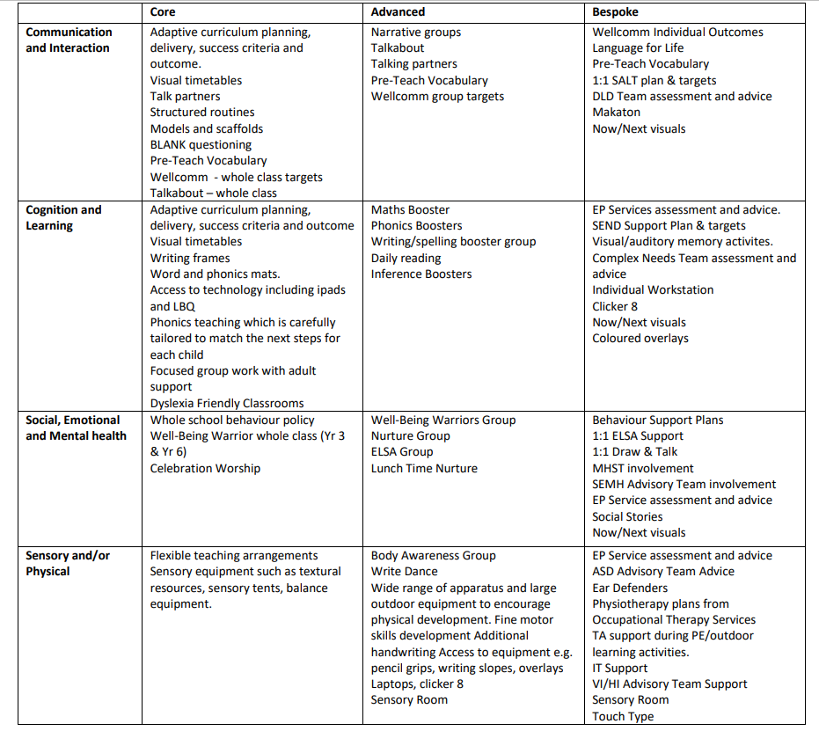

We also follow Blackburn with Darwen’s High Quality Inclusive Teaching Framework which can be found under the SEND tab on our website and we use Blackburn with Darwen’s Graduated Approach and reasonable adjustments for learning.

9. How will the school evaluate whether the support in place is helping my child?

We will evaluate the effectiveness of provision for your child by:
- Reviewing their progress towards their goals each term- Star Maps
- Reviewing the impact of interventions after 6 weeks
- Using pupil questionnaires
- Monitoring by the SENCO
- Using provision maps to measure progress
- Holding SEN support meetings where parents, professionals involved, children, and teachers feed back on progress.
- Holding an annual review (if they have an education, health and care (EHC) plan)
- Reassessment on SENCO assessments to see whether gaps have been filled and progress is getting better.
- End of term assessments.

10. How will the school resources be secured for my child?
It may be that your child’s needs mean we need to secure:
- Extra equipment or facilities
- Group support
- Further training for our staff
- Specific interventions
- Time with our school-based tutor.
- External specialist expertise
- Certain interventions
- Time with our school ELSA team/ nurture lead.
If that’s the case, we will consult with external agencies to get recommendations on what will best help your child access their learning.
The school will cover up to £6,000 of any necessary costs. If funding is needed beyond this, we will seek it from our local authority either through Emergency High Needs Funding which is for emergency situations where children need funding immediately, or through the application of an EHCP- can only be secured once all agencies who need to be involved have given recommendations and school has embedded them, and if your child has exceptional needs compared to those within the borough.

11. How will the school make sure my child is included in activities alongside pupils who don’t have SEN?
All of our extra-curricular activities and school visits are available to all our pupils, including our before and after-school clubs. We have a list of children on SEND and PP register and will ensure that we prioritise pupils who have not yet experienced a club in school.
All pupils are encouraged to go on our school trips, including our residential trips including our Y2 and 5 residentials.
All pupils are encouraged to take part in sports days, musical performances, choir and trips out of school for sporting events. We monitor our children on SEND and PP register and ensure they get the opportunity to be involved, as well as taking part
No pupil is ever excluded from taking part in these activities because of their SEN or disability and we will make whatever reasonable adjustments are needed to make sure they can be included.

12. How does the school make sure the admissions process is fair for pupils with SEN or a disability?

Our school admits pupils with EHCPs or those in care as priority as long as we can meet their needs. Children with EHCPs are higher in the criteria than all other pupils. Only children with EHCP’s are admitted on SEN basis, unless there are medical reasons that The Redeemer would be the only school suitable for your child and a doctor or medical specialist would have to sign to say that this information is correct.

13. How does the school support pupils with disabilities?
- All pupils with disabilities will be included in all aspects of school and adjustments will be made to ensure they are involved in the full school offer.
- It is all built on one level making it wheelchair friendly with spacious rooms. There is an accessible bathroom, shower room, and sensory room built within school. Having pupils with VI need has ensured that areas of danger are demarcated using high coloured tape.
  - Please see our accessibility plan on the website under the SEND tab or follow the link 8344E94C53D632C1741147F61EF4BE53.pdf

14. How will the school support my child’s mental health, and emotional and social development?
We provide support for pupils to progress in their emotional and social development in the following ways:
- Pupils with SEN are encouraged to be part of the whole school offer.
- Pupils with SEN are also encouraged to be part of clubs, societies and sporting teams.
- We provide extra support for children with SEMH needs, Mental health needs, or worries, anxieties, or needing to discuss difficult times by giving access to an ELSA trained member of staff. There are four ELSA trained members of staff including Kay Mayfield, Debbie Cocker, Joanne Derbyshire, and Khloe Jones. Our family support worker, Kay, also provides settle in sessions for children with separation anxiety as well as running specific therapies for those who need it.
- We run a nurture session for children who need further time with adults.
- Our PSHE curriculum has specific plans on wellbeing, looking after mental health, and ensuring that children know who to speak to in certain circumstances.
- We have wellbeing ambassadors- children who have opted to support the wellbeing lead in hearing the voices of pupils and sharing ideas on how to make school a happy place to be.
- All staff are involved in regular training and updates on how/ what resources/ and what a healthy, happy classroom looks like, and building relationships is the key to ensuring children are happy in school.
- We have a ‘No Shouting’ policy and instead try to redirect children to what they should be doing instead of highlighting what they shouldn’t be doing.
- We have close links with mental health services and have workshops available in school to support the mental health of parents of children with worries.
- We have a secure referral system to NHS mental health teams, and have a number of children who access specific medical support for mental wellbeing.
We have a ‘zero tolerance’ approach to bullying. All children are aware of what the definition of bullying is, and can speak to staff at any time about any situation that is causing them worry.

15. What support will be available for my child as they transition between classes or settings, or in preparing for adulthood?
As a school, we regularly review our policies on how we transition children from class to class and from school to school. Our Year 6 children transition by having days where they experience their new high school, and our school is involved in a handover day, where SENCOs meet to discuss the needs of pupils and ensure that children are getting the correct adjustments in secondary school. Our EYFS team visit nurseries and homes, and the SENCO will meet with nursery SENCO’s to ensure we have the correct provision in place for pupils. We will always support children struggling with transition through the use of move up days, extra time with their new teacher, social stories, and through parent/ school communication. At present we mix classes in Y1, Y3 and Y5 in order to ensure that friendship groups, children with SEND, children with different learning styles, and children who work well together are split. We are currently reviewing how this is done for 2025/26 after feedback from last year’s splits considering parent view and pupil views. We have handover sessions where documentation is shared for each pupil, highlighting any strengths, needs, difficulties, likes/ dislikes, and how best to help that learner to achieve, and these form the basis of building new relationships between class teacher and children upon transition. Each year, the SENCO will share all SEND information with new teachers/ TA’s in meetings, and all staff have copies of reasonable adjustments for each child available in a profile in the classroom to ensure no information is missed.

Between years
To help pupils with SEN be prepared for a new school year we:
- Ask both the current teacher and the next year’s teacher to attend a final meeting of the year when the pupil’s SEN is discussed
- Schedule sessions/ jobs with the incoming teacher towards the end of the summer term
- Have detailed handovers where information sharing is recorded and stored.
- Have a whole school ‘safe information sharing’ document, where friendships, learning information, and reasonable adjustments/ professional involvement is shared with staff.
- Provide social stories that include pictures of where a child is moving to, the classroom environment, the door they will enter/ exit through, and the necessary teacher information before the school break starts.
- Review procedures annually to ensure that previous feedback informs new decisions surrounding transition.
Between schools
When your child is moving on from our school, we will ask you and your child what information you want us to share with the new setting.
The SENCO of the secondary school will meet our SENCO and a SEND transition document will be shared alongside a pack of information. They will discuss the needs of all the children who are receiving SEN support. For those with EHCP’s, their current 1:1 will support them in the transition days if needed. (especially in the case of those going to specialist provision). Where supported by the secondary schools, extra transition will be arranged.
Pupils will be prepared for the transition by:
- Practising with a secondary school timetable
- Learning how to get organised independently
- Plugging any gaps in knowledge
- The sharing of advisory teacher recommendations.
- Building independence before transition.

New starters (Reception)
The SENCO of the primary school meets with nursery SENCO’s / advisory teachers to discuss the needs of the incoming pupils near the end of the summer term.
We arrange meetings with the parents/carers of incoming pupils to discuss how we can best welcome their child into our community if they have specific SEND needs or concerns.
We set up new pupils with a buddy from the Year 6, to help them get settled in and make friends and to give them a responsible child to talk to if needed.
All children in Reception will be baselined using:
BPVS- receptive vocabulary
WELCOMM- language tool
Baseline assessments EYFS- maths/ English
TALC- Blank levels of questioning.
SALT- speech sounds for any children who are struggling to pronounce letters/ words.

16. What support is in place for looked-after and previously looked-after children with SEN?

Luke Devine will work with Natalie Woodhouse our SENCO and Virtual Schools, to make sure that all teachers understand how a looked-after or previously looked-after pupil’s circumstances and their SEN might interact, and what the implications are for teaching and learning.
Children who are looked-after or previously looked-after will be supported much in the same way as any other child who has SEN. However, looked-after pupils will also have a personal education plan (PEP). We will make sure that the PEP and any SEN support plans or EHC plans are consistent and complement one another.

17. What should I do if I have a complaint about my child’s SEN support?
Complaints about SEN provision in our school should be made to the headteacher in the first instance. They will then be referred to the school’s complaints policy.
If you are not satisfied with the school’s response, you can escalate the complaint. In some circumstances, this right also applies to the pupil themselves.
SENDIASS are a service available within Blackburn With Darwen to support families and work alongside schools to ensure children with SEND get the correct provision.

18. What support is available for me and my family?
If you have questions about SEN, or are struggling to cope, please get in touch to let us know. We want to support you, your child and your family.
To see what support is available to you locally, have a look at Blackburn with Darwen local offer. Blackburn with Darwen Local Authority publishes information about the local offer on their website:
Local offer directory | Blackburn with Darwen Borough Council
Our local special educational needs and disabilities information, advice and support (SENDIAS) services are:
If you have support in place, and it is not enough | Blackburn with Darwen Borough Council
Local charities that offer information and support to families of children with SEN are:
Home page - CANW supporting families with Autism or mental health.
ADHD North West | Suite 10, The Chambers, Town Hall Square, Great Harwood BB6 7DD Supporting families with children with ADHD
Lancashire and South Cumbria Thrive Service | Barnardo's Offering mental health support.

National charities that offer information and support to families of children with SEN are:
- IPSEA
- SEND family support
- NSPCC
- Family Action
- Special Needs Jungle

19. Glossary
- Access arrangements – special arrangements to allow pupils with SEN to access assessments or exams
- Annual review – an annual meeting to review the provision in a pupil’s EHC plan
- Area of need – the 4 areas of need describe different types of needs a pupil with SEN can have. The 4 areas are communication and interaction; cognition and learning; physical and/or sensory; and social, emotional and mental health needs
- CAMHS – child and adolescent mental health services
- Differentiation – when teachers adapt how they teach in response to a pupil’s needs
- EHC needs assessment – the needs assessment is the first step on the way to securing an EHC plan. The local authority will do an assessment to decide whether a child needs an EHC plan
- EHC plan – an education, health and care (EHC) plan is a legally-binding document that sets out a child’s needs and the provision that will be put in place to meet their needs
- First-tier tribunal / SEND tribunal – a court where you can appeal against the local authority’s decisions about EHC needs assessments or plans and against discrimination by a school or local authority due to SEN
- Graduated approach – an approach to providing SEN support in which the school provides support in successive cycles of assessing the pupil’s needs, planning the provision, implementing the plan, and reviewing the impact of the action on the pupil
- Intervention – a short-term, targeted approach to teaching a pupil with a specific outcome in mind
- Local offer – information provided by the local authority that explains what services and support are on offer for pupils with SEN in the local area
- Outcome – target for improvement for pupils with SEN. These targets don't necessarily have to be related to academic attainment
- Reasonable adjustments – changes that the school must make to remove or reduce any disadvantages caused by a child’s disability
- SENCO – the special educational needs co-ordinator
- SEN – special educational needs
- SEND – special educational needs and disabilities
- SEND Code of Practice – the statutory guidance that schools must follow to support children with SEND
- SEN information report – a report that schools must publish on their website, that explains how the school supports pupils with SEN
- SEN support – special educational provision that meets the needs of pupils with SEN
- Transition – when a pupil moves between years, phases, schools or institutions or life stages

