**Chess Help Sheet** *(with clickable links)*

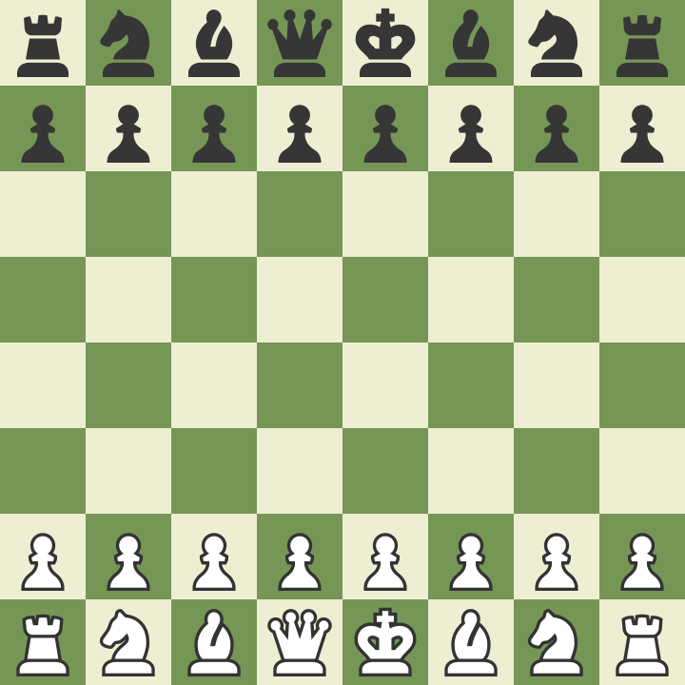**The Layout**

**The Pieces**

|  |  |  |
| --- | --- | --- |
| Pawn |  | <https://www.youtube.com/watch?v=AdhhG13bIvc> |
| Rook |  | <https://www.youtube.com/watch?v=jms91e5ULNI> |
| Knight |  | <https://www.youtube.com/watch?v=VsWL5AqNokk> |
| Bishop |  | <https://www.youtube.com/watch?v=MKLW3oh7_wE> |
| Queen |  | <https://www.youtube.com/watch?v=AKZl3pSN1Cs> |
| King |  | <https://www.youtube.com/watch?v=iwcQFMRYOdU> |

**Getting Started**

Place a white and black piece in each hand. Mix them up and your opponent gets the colour they choose.

White always moves first.

**Check** – To put the king under the threat of capture. You must say it after you have put the king in check.

<https://www.youtube.com/watch?v=C6bqDvAZVTk>

**Checkmate** – To trap the king, giving it no possible escape, winning the match. You should also say checkmate.

<https://www.youtube.com/watch?v=Svswkqslr9I>

**Resign** – To accept defeat before you are put in checkmate. You usually shake hands to show resignation.

**‘Control the Centre’** – Starting your match by trying to control the central squares

<https://www.youtube.com/watch?v=B7CT0kOm8Jk>

**Castling** – A special move to switch the rook and king. Castle early, castle often. <https://www.youtube.com/watch?v=-NE2R2IAddc>

**En Passant** – A special capture a pawn can do

<https://www.youtube.com/watch?v=0I-PAaAMmSA>

**Pin** – When you trap your opponent’s piece in between another.

<https://www.youtube.com/watch?v=sjpKC9SMvKs>

**Fork** – When you attack more than one piece at the same time

<https://www.youtube.com/watch?v=mgAbXPBeVEI>

**Skewer** – An attack upon two pieces in the same line

<https://www.youtube.com/watch?v=2KlDixnZMhM>